**AN ANALYSIS FOR NVDIA STOCK PRICE’S FOR**

**THE PAST 25 YEARS**

**OVERVIEW**

This is and analysis made for the purpose of visualizing the sales of stocks that NVIDIA has made for the past 25 years, NVIDIA made their announcement on in the final quarter of 2024 that their GAAP earnings per diluted share for the quarter of the year was $60.9 billion and was up by 126% from the previous year, the earnings were $11.93 and 586% and their Non-GAAP earnings were $12.96 and up by 288%. A new computer era has begun and companies worldwide are transitioning from general purpose to accelerated computing and generating AI .

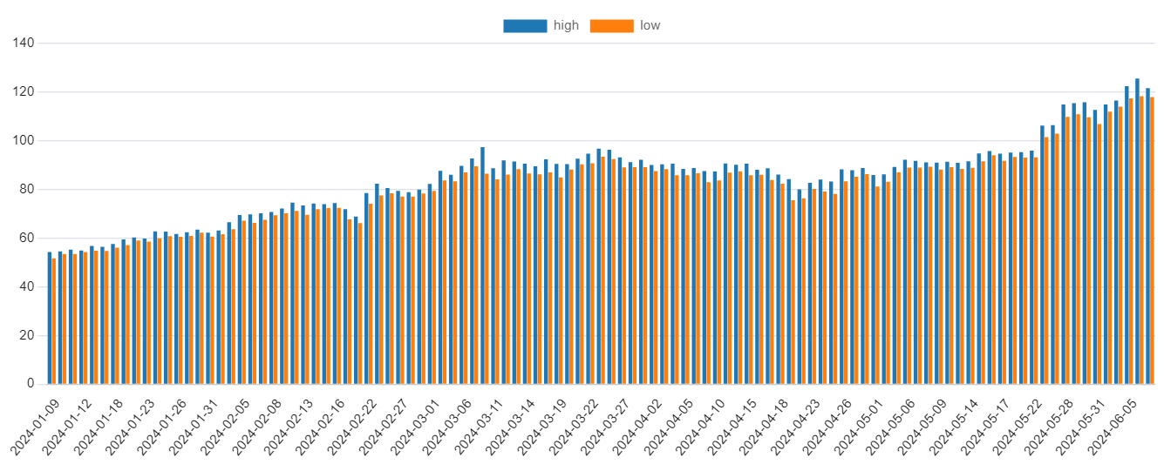

The bar chart above shows the high and low price sales that NVIDIA has made for the quarter of the year 2024, and it was during this quarter that the company has manged to return about $3.38 billion back to their shareholders in the form of $7.5 million shares repurchased for $3.28 billion and cash dividends.

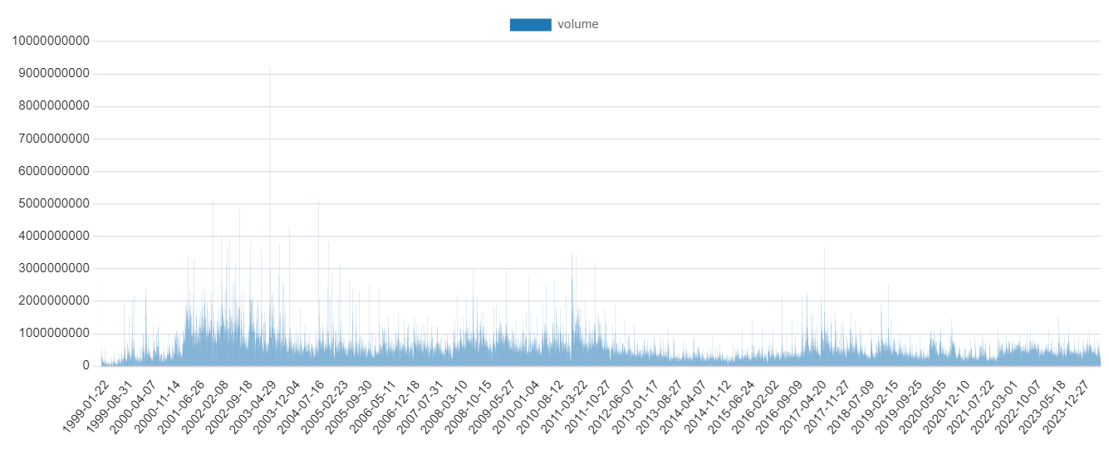

The next chart shows the volume measurement of sales that NVIDIA has made since 1999 to 2024 and as we can see their sales volume has risen from a considerable amount since 1999 with their peak being (2003-05-12) as shown below.

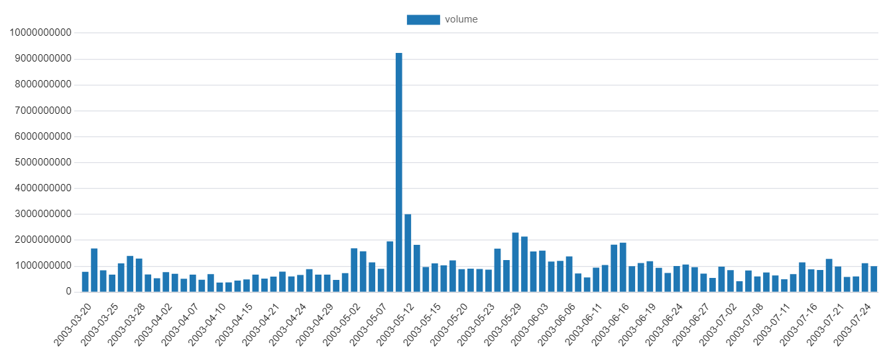

This could have happened because of the rise of technology in the early 2003 and caused their sales to explode, they also made the least sales in the year 1999 as shown below.

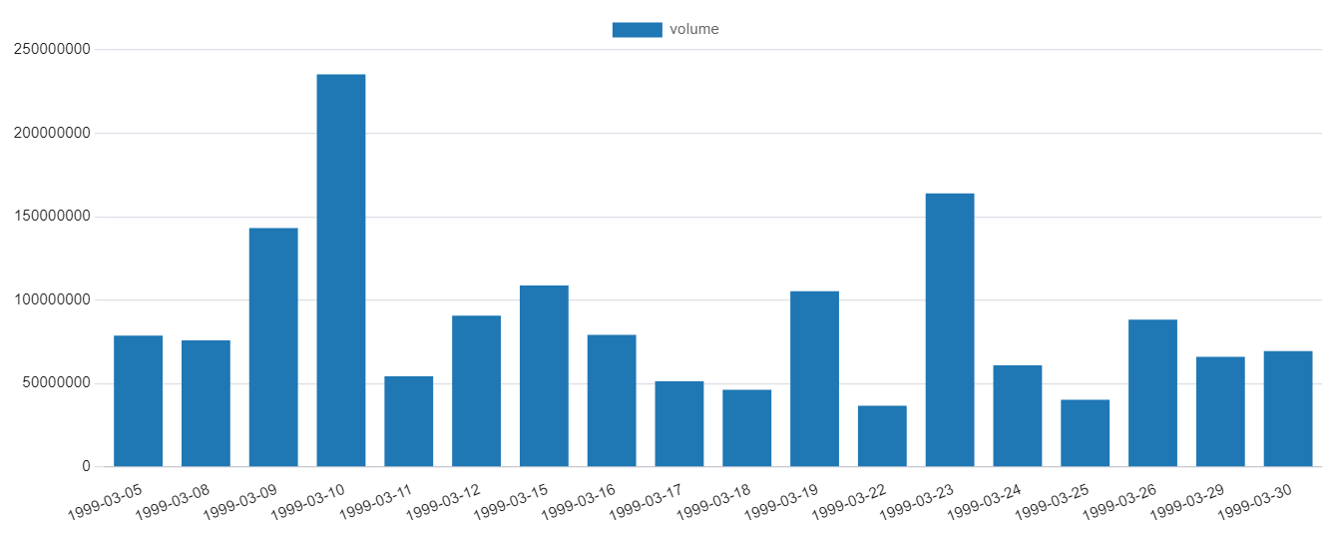

This can be linked to their company still being in its early stages and trying to make a name for itself.

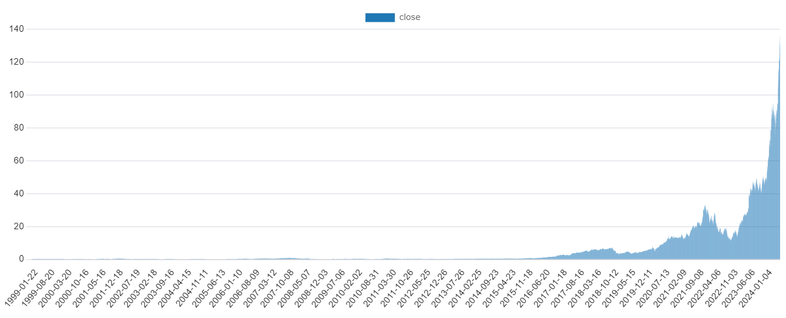

The last bar chart above shows their closing sales for the past 25 years and as we can clearly see it continues to keep on rising due to the amount of sales begin made.

**Material Used**

Post SQL for Database

pg Admin 4 for Plotting Charts

pg Admin 4 for Data flow

**Personal Observation**

From my observation NVIDIA witnessed a huge increase in sales for the past 25 years and will obviously continue to witness an even greater increase in sales as more years come because of the numerous advancement in technology and dependence for stronger GPU’s